Course: Data Science Roll No: TYCS-12

Aim: Practical on Hypothesis Testing.

__________________________________________________________________________________

Output 1

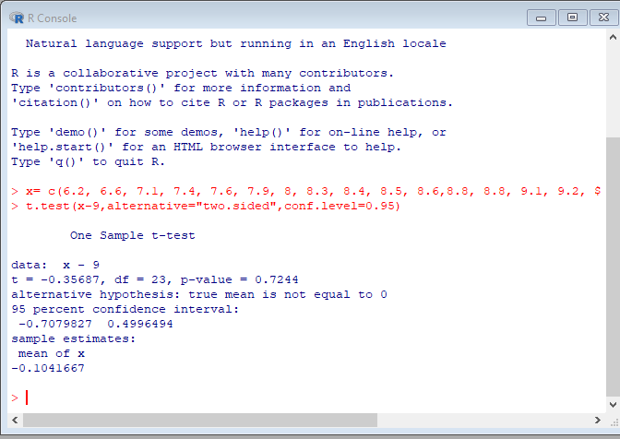

Output 2

